**Installing IBM Cloud CLI and plugins in offline mode**

Procedure Guide

Record of revisions

|  |  |  |
| --- | --- | --- |
| Issue | Date | Summary and reasons for changes |
| V1.0 | October 10th 2020 | Document Initiation |

Acronyms

| Acronym | Meaning |
| --- | --- |
|  |  |
|  |  |
|  |  |
|  |  |

Reference documents

|  |  |  |
| --- | --- | --- |
| Reference  Number | Title | Issue |
|  |  |  |
|  |  |  |
|  |  |  |
|  |  |  |

Glossary

|  |  |  |
| --- | --- | --- |
| Term | Synonym | Meaning |
|  |  |  |

TABLE OF CONTENTS

Record of revisions 2

Acronyms 2

Reference documents 2

Glossary 2

1 Introduction 4

1.1 Purpose and scope of document 4

2 Preparing IBM Cloud CLI installer and plugins 5

2.1 Locating IBM Cloud CLI and Plugins 5

2.2 Installation 5

2.3 Download a plugin 6

Table List

No table of figures entries found.

**Figure List**

Figure 1. IBM Cloud CLI in Github 5

1. Introduction
   1. Purpose and scope of document

The objective and purpose of this document is to explain the steps for installing IBM Cloud CLI and associated plugins in offline mode.

1. Preparing IBM Cloud CLI installer and plugins
   1. Locating IBM Cloud CLI and Plugins

The IBM Cloud CLI installer and the plugins can be found on this GitHub repository:

<https://github.com/kriad85/ibmcloud-cli-repo>

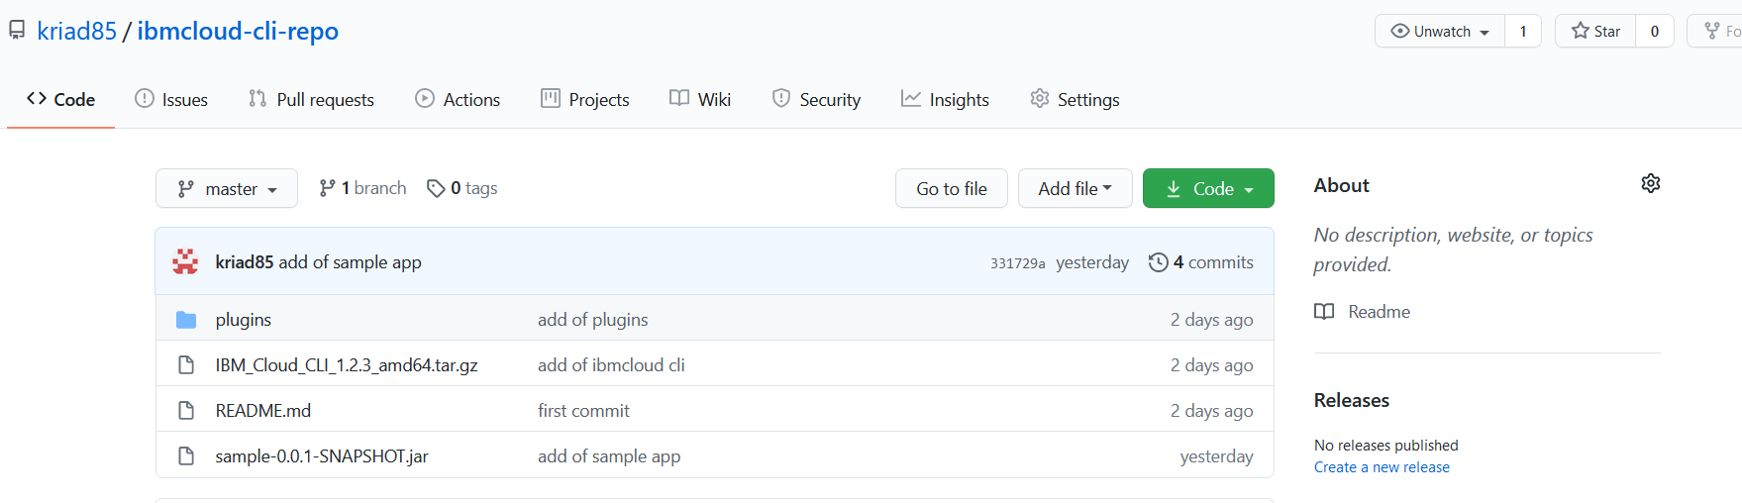

1. IBM Cloud CLI in Github

The plugins folder contains the ones for installing the container service, container registry and the cloud object storage.

* 1. Installation

On a Linux VM, clone the above repository and run the following:

|  |
| --- |
| git clone <https://github.com/kriad85/ibmcloud-cli-repo>  cd ibmcloud-cli-repo/  tar xzf IBM_Cloud_CLI_1.2.3_amd64.tar.gz  cd Bluemix_CLI/  ./install  cd plugins/  cd cloud-object-storage/  ibmcloud plugin install ./cloud-object-storage  cd container-registry/  ibmcloud plugin install ./container-registry  cd container-service/  ibmcloud plugin install ./container-service |

* 1. Download a plugin

In case a plugin is needed, we can use IBM Cloud CLI to download the plugin from a VM connected to Internet.

For example, the following command fetches the cloud databases command:

|  |
| --- |
| ibmcloud plugin install cloud-databases |

The plugin will be available in the following path:

***/$user$/.bluemix/plugins/cloud-databases***